# CHAPTER - 1 INTRODUCTION

## 1.1 PROJECT DESCRIPTION

Mental health disorders, particularly depression, represent one of the most significant public health challenges of the 21st century. According to the World Health Organization, depression affects more than 280 million people worldwide and is the leading cause of disability globally. Despite its prevalence, depression remains significantly under-diagnosed and under-treated, with many individuals suffering in silence due to stigma, lack of access to mental health services, or inability to recognize the symptoms.

The traditional approach to depression assessment relies heavily on clinical interviews and standardized questionnaires such as the Patient Health Questionnaire-9 (PHQ-9) and the Beck Depression Inventory (BDI-II). While these instruments provide valuable clinical insights, they require professional administration and often fail to capture the dynamic nature of depressive symptoms that can fluctuate over time. Moreover, the subjective nature of self-reporting can lead to inconsistencies and may not accurately reflect the true severity of an individual's condition.

In recent years, the proliferation of digital communication platforms and social media has created unprecedented opportunities for passive mental health monitoring. People increasingly express their thoughts, emotions, and experiences through text-based communication, creating a rich repository of linguistic and emotional data that can potentially serve as indicators of mental health status. This digital phenotyping approach offers the possibility of continuous, unobtrusive monitoring of psychological well-being.

The Depression Intensity Analyzer (DIA) project addresses this opportunity by developing a comprehensive web-based application that leverages state-of-the-art Natural Language Processing (NLP) and Deep learning techniques to automatically assess depression severity from textual input. The system is designed to bridge the gap between traditional clinical assessment methods and modern digital health technologies, providing an accessible, scalable, and objective tool for depression screening and monitoring.

The core innovation of this project lies in its dual-mode operation capability. In automatic mode, the system employs a pre-trained transformer-based emotion detection model (j-hartmann/emotion-english-distilroberta-base) to automatically extract emotional features from user-provided text. In manual mode, users can directly adjust emotional intensity sliders, providing flexibility for different use cases and user preferences. This hybrid approach ensures that the system can accommodate various types of input while maintaining high accuracy in depression assessment.

The technical architecture of the DIA system is built upon a sophisticated Deep learning pipeline that combines multiple advanced techniques. At its foundation is a dual-output Keras deep learning model that simultaneously predicts both depression intensity on a continuous scale (0-4) and discrete severity classifications (No Depression, Mild, Moderate, Severe, Very Severe). This dual-output approach provides both granular intensity measurements for clinical applications and categorical classifications that align with established diagnostic frameworks.

The system's feature engineering component is particularly noteworthy, as it combines emotion vectors derived from transformer models with traditional sentiment analysis metrics and linguistic features. This multi-dimensional feature space captures various aspects of language that may indicate depressive symptoms, including emotional tone, linguistic complexity, and semantic content. The integration of these diverse features creates a robust representation that can detect subtle patterns associated with different levels of depression severity.

One of the key advantages of the DIA system is its real-time processing capability. Built on the Flask web framework, the application can process text input and generate predictions within milliseconds, making it suitable for interactive applications and real-time monitoring scenarios. The responsive web interface, enhanced with Chart.js visualizations, provides users with intuitive gauge charts that clearly communicate risk levels and intensity scores.

The project also addresses critical ethical and privacy considerations in mental health technology. The system incorporates built-in safeguards for detecting high-risk cases and includes appropriate disclaimers about the limitations of automated assessment tools.

Data handling procedures are designed to comply with privacy regulations, and the system architecture supports secure, encrypted storage of sensitive information.

From a clinical perspective, the DIA system is designed to complement, not replace, traditional mental health assessment and treatment approaches. The system provides standardized, objective measurements that can assist healthcare professionals in screening, monitoring, and treatment planning. By automating the initial assessment process, the system can help identify individuals who may benefit from professional mental health services while reducing the burden on healthcare systems.

The development methodology employed in this project follows established software engineering practices, incorporating comprehensive testing, validation, and performance optimization procedures. The Deep learning components are trained and validated using established datasets and performance metrics, ensuring reliability and generalizability across different populations and use cases.

## 1.2 OBJECTIVES

The primary objectives of the Depression Intensity Analyzer project are multifaceted and designed to address various aspects of automated mental health assessment through advanced Deep learning and natural language processing techniques.

**1.2.1 Accurate Depression Severity Assessment**

The foremost objective of this project is to develop a highly accurate system for assessing depression severity from textual input. This involves creating a Deep learning model capable of analyzing various forms of text, including social media posts, journal entries, and conversational text, to determine the likelihood and intensity of depressive symptoms. The system aims to achieve clinical-grade accuracy in distinguishing between different levels of depression severity, from no depression to very severe cases.

The accuracy target for this system is established through comparison with validated clinical assessment tools such as the PHQ-9 and BDI-II. The model should demonstrate strong correlation with these established instruments while providing additional granularity through continuous intensity scoring. This objective requires extensive validation using clinically annotated datasets and comparison with human expert assessments.

**1.2.2 Development of Dual-Mode Processing Capability**

A critical objective is the implementation of a flexible dual-mode processing system that can operate in both automatic and manual modes. In automatic mode, the system should seamlessly extract emotional features from raw text using advanced transformer-based models. In manual mode, users should be able to directly manipulate emotional intensity parameters through an intuitive interface. This dual-mode capability serves multiple purposes: it provides flexibility for different use cases, allows for system validation through manual input comparison, and enables users to understand the relationship between emotional states and depression assessment. The objective includes ensuring that both modes produce consistent and reliable results while maintaining user-friendly operation.

**1.2.3 Integration of Multiple AI Technologies**

The project aims to successfully integrate multiple artificial intelligence technologies into a cohesive system. This includes combining transformer-based language models for emotion detection, traditional sentiment analysis algorithms, custom neural networks for depression prediction, and web-based visualization technologies.

The integration objective requires careful consideration of data flow, processing efficiency, and model compatibility. Each component must work seamlessly with others while maintaining individual performance standards. This objective also includes optimizing the overall system performance to ensure real-time processing capabilities.

**1.2.4 Clinical Alignment and Validation**

An essential objective is ensuring that the system's output aligns with established clinical frameworks and diagnostic criteria. The depression intensity scale (0-4) and severity classifications must correspond to recognized clinical categories. The risk assessment component should provide meaningful information that can assist healthcare professionals in screening and triage decisions.

This objective includes comprehensive validation against clinical gold standards, comparison with existing assessment tools, and evaluation by mental health professionals. The system should demonstrate utility in clinical settings while maintaining appropriate limitations and disclaimers about its role as a screening rather than diagnostic tool.  
  
**1.2.5 User Experience and Accessibility**

The project aims to create an intuitive, accessible, and engaging user interface that encourages appropriate use while providing clear, actionable feedback. The web-based interface should be responsive, visually appealing, and capable of effectively communicating complex assessment results through simple visualizations.

This objective includes developing appropriate user guidance, implementing clear visual feedback mechanisms, and ensuring that the system can be used by individuals with varying levels of technical expertise. The interface should also include appropriate privacy safeguards and user consent mechanisms.

**1.2.6 Scalability and Performance Optimization**

The system should be designed for scalability, capable of handling multiple concurrent users while maintaining consistent performance. This objective includes optimizing model inference times, implementing efficient data processing pipelines, and designing system architecture that can accommodate future enhancements and increased usage. Performance targets include response times under 200 milliseconds for typical text processing tasks and the ability to handle at least 100 concurrent users without significant performance degradation. The system should also be designed for easy deployment across different computing environments.

**1.2.7 Ethical AI Implementation**

A crucial objective is implementing ethical AI practices throughout the system development and deployment process. This includes ensuring fairness across different demographic groups, implementing appropriate privacy protections, providing transparency in model decision-making, and establishing clear guidelines for appropriate system use.

The ethical implementation objective also includes developing appropriate safeguards for high-risk cases, implementing user consent mechanisms, and providing clear information about system limitations and potential risks. The system should be designed to minimize potential harm while maximizing benefits for users and healthcare providers.

**1.2.8 Research and Development Contribution**

The project aims to contribute to the broader research community through the development of novel techniques for automated mental health assessment. This includes documenting methodology, sharing findings, and contributing to the understanding of how AI technologies can be effectively applied to mental health challenges.

This objective includes publishing research findings, sharing code and methodologies where appropriate, and contributing to the development of best practices for AI-based mental health applications. The project should serve as a foundation for future research and development in this critical area.

## 1.3 SYSTEM OVERVIEW

The Depression Intensity Analyzer represents a sophisticated integration of multiple artificial intelligence technologies designed to provide comprehensive mental health assessment capabilities. The system architecture follows a modular design pattern that enables flexible deployment, easy maintenance, and scalable performance.

**1.3.1 System Architecture Overview**

The DIA system is built upon a layered architecture that separates concerns while enabling seamless integration between components. The presentation layer consists of a responsive web interface built with modern HTML5, CSS3, and JavaScript technologies. This layer provides user interaction capabilities, including text input, emotion slider controls, and visualization of assessment results through interactive Chart.js gauge displays.

The application layer is implemented using the Flask web framework, providing RESTful API endpoints for system interaction. This layer handles request processing, user session management, and coordination between different system components. The Flask framework was chosen for its lightweight nature, extensive documentation, and strong integration capabilities with Python-based Deep learning libraries.

The business logic layer contains the core assessment algorithms, including the emotion detection pipeline, feature engineering modules, and the depression prediction model. This layer implements the dual-mode processing capability, allowing for both automatic emotion extraction from text and manual emotion parameter adjustment

The data access layer manages all data operations, including model loading, temporary data storage, and result caching. This layer is designed to support future enhancements such as user data persistence and historical assessment tracking.

**1.3.2 Emotion Detection Pipeline**

The emotion detection component utilizes the j-hartmann/emotion-english-distilroberta-base model, a state-of-the-art transformer-based architecture specifically fine-tuned for emotion classification tasks. This model is capable of identifying six primary emotions: joy, sadness, anger, fear, surprise, and disgust, along with their respective intensity levels.

The pipeline preprocessing stage includes text normalization, tokenization, and preparation for transformer input. The model processes input text through multiple attention layers, generating contextualized embeddings that capture semantic and emotional content. The output consists of probability distributions across emotion categories, which are then normalized and scaled for integration with the depression prediction model.

To ensure robust performance across different text types and lengths, the system implements adaptive preprocessing strategies. Short texts are padded appropriately, while longer texts are segmented and processed in chunks, with results aggregated using weighted averaging techniques.

To ensure robust performance across different text types and lengths, the system implements adaptive preprocessing strategies. Short texts are padded appropriately, while longer texts are segmented and processed in chunks, with results aggregated using weighted averaging techniques.

**1.3.3 Feature Engineering Framework**

The feature engineering component represents a critical innovation in the DIA system, combining multiple types of linguistic and emotional features to create a comprehensive representation of mental health indicators. The framework operates on three primary feature categories.

Emotion-based features derived from the transformer model provide high-dimensional representations of emotional content. These features capture subtle emotional nuances that may not be apparent through traditional sentiment analysis approaches.

Sentiment-based features utilize TextBlob library to extract polarity and subjectivity measures. These features provide complementary information about overall emotional tone and objectivity of the text.

Linguistic features include various text-based metrics such as word count, sentence complexity, use of first-person pronouns, and negation frequency. Research has shown that these linguistic patterns can be indicative of depressive symptoms and cognitive patterns associated with mental health conditions.

The integration of these diverse feature types creates a robust, multi-dimensional representation that enables the depression prediction model to capture complex patterns associated with different levels of depression severity.

**1.3.4 Depression Prediction Model**

The core prediction model utilizes a dual-output neural network architecture implemented in TensorFlow/Keras. This design simultaneously produces both continuous intensity scores and discrete severity classifications, providing flexibility for different application scenarios.

The model architecture consists of shared dense layers that process the integrated feature vector, followed by two specialized output heads. The regression head produces continuous intensity scores on a 0-4 scale, while the classification head generates probability distributions across five severity categories.

The training process utilizes a combined loss function that weights both regression and classification objectives, ensuring that the model optimizes for both accurate intensity prediction and reliable categorical classification. This approach has been shown to improve overall model performance compared to single-output alternatives.

**1.3.5 Risk Assessment and Mapping**

The risk assessment component translates model predictions into clinically meaningful risk categories. The mapping system is based on established clinical thresholds and validated through comparison with standard assessment instruments.

The risk categorization follows a five-level system: Low Risk (intensity < 1.0), Mild Risk (1.0 ≤ intensity < 2.0), Moderate Risk (2.0 ≤ intensity < 2.7), High Risk (2.7 ≤ intensity < 3.5), and Very High Risk (intensity ≥ 3.5). These thresholds were established through analysis of clinical data and validation against expert assessments.

The system also implements special handling for high-risk cases, including appropriate warning messages and recommendations for professional consultation. This safeguard mechanism ensures that users receive appropriate guidance when assessment results indicate significant mental health concerns.

**1.3.6 User Interface and Visualization**

The user interface design prioritizes clarity, accessibility, and user engagement while maintaining professional appearance suitable for healthcare applications. The interface supports both desktop and mobile devices through responsive design principles.

The main interaction area includes text input fields for automatic mode processing and intuitive slider controls for manual emotion adjustment. Real-time feedback provides users with immediate assessment results, encouraging engagement and exploration of the system capabilities.

The visualization component utilizes Chart.js to create interactive gauge charts that clearly communicate risk levels and intensity scores. The semicircular gauge design provides intuitive visual feedback while maintaining professional appearance appropriate for healthcare applications.

**1.3.7 Performance and Scalability Considerations**

The system is designed for high-performance operation with typical response times under 200 milliseconds for standard text processing tasks. Model optimization techniques, including quantization and caching strategies, ensure efficient resource utilization.  
The architecture supports horizontal scaling through containerization and microservice deployment patterns. This design enables the system to handle increased user loads while maintaining consistent performance characteristics.

Memory management strategies include efficient model loading, result caching, and automatic cleanup of temporary processing data. These optimizations ensure stable operation even under sustained high-usage scenarios.

**1.3.8 Security and Privacy Framework**

The system implements comprehensive security measures to protect user data and ensure privacy compliance. All text processing occurs server-side with immediate cleanup of temporary data, minimizing privacy exposure.

Data transmission utilizes HTTPS encryption, and the system architecture supports integration with additional security measures such as user authentication and audit logging. These features provide a foundation for deployment in healthcare environments with strict privacy requirements.

The system design also includes provisions for compliance with regulations such as GDPR and HIPAA, including user consent mechanisms, data retention policies, and user data deletion capabilities.

# CHAPTER - 2 LITERATURE SURVEY

## 2.1 LITERATURE SURVEY

**2.1.1 Title: Text-Based Depression Detection on Social Media Posts:** A Systematic Literature Review

**Authors:** Shen, Y., Rudzicz, F., & Araki, K. (2020**)**

**Summary:** This paper presents a comprehensive review of text-based depression detection methods applied to social media data. The authors evaluate various natural language processing (NLP) and machine learning techniques used in past research, highlighting common datasets, feature extraction approaches, and classification algorithms. The review identifies key challenges, such as data privacy concerns, annotation inconsistencies, and generalization across platforms. It emphasizes the growing importance of deep learning models and calls for standardized evaluation metrics and ethically responsible methodologies.

**2.1.2 Title: Instagram Photos Reveal Predictive Markers of Depression**

**Authors:** Reece, A. G., & Danforth, C. M. (2017)

**Summary:** This study explores how visual content shared on Instagram can serve as an indicator of depressive behavior. By analyzing color, brightness, and facial expressions in images posted by users, along with metadata like filters and engagement patterns, the authors trained classifiers to distinguish between depressed and non-depressed individuals. The results suggest that depressed users tend to post photos that are darker, bluer, and less vibrant. This pioneering work demonstrates the potential of image-based features in mental health analysis.

### 2.1.3 Title: Depression Detection on Social Media: A Classification Framework and Research Challenges

### Authors: Gui, G., Xu, L., Liu, Y., & Gong, Y. (2020)

**Summary:** This paper introduces a structured framework for classifying depression from social media data using machine learning. It outlines key components such as data collection, preprocessing, feature engineering, and model evaluation.

The authors also discuss open challenges in the field, including linguistic ambiguity, limited labeled data, and cross-platform variability. They argue for the need to combine textual, behavioral, and contextual signals to enhance classification performance.

**2.1.4 Title: Depression Intensity Estimation via Social Media: A Deep Learning Approach**

**Authors:** Ghosh, S., & Anwar, T. (2021)

**Summary:** This research proposes a deep learning model to estimate the intensity of depression expressed in social media posts. Unlike traditional binary classification, the model predicts varying levels of depressive severity using labeled data. It incorporates convolutional neural networks (CNNs) and recurrent structures to capture both local and sequential features in text. The paper highlights that deep learning models outperform classical machine learning approaches in accurately estimating depression levels.

**2.1.5 Title: DepressMind: A System for Mining Twitter and Reddit to Analyze Depression Symptoms**

**Authors:**Anwar, S., & Ghosh, S. (2022)

**Summary:** The authors introduce DepressMind, an AI-based system designed to analyze symptoms of depression by mining data from Twitter and Reddit. The system employs NLP techniques for preprocessing, feature extraction, and classification, targeting both explicit and implicit signs of mental distress. The study emphasizes real-time data collection and scalable model deployment, suggesting practical use in mental health monitoring and early intervention.

**2.1.6 Title: Align Before Fuse: Vision and Language Representation Learning with Momentum Distillation**

**Authors:** Li, J., Selvaraju, R. R., Gotmare, A., et al. (2021)

**Summary:** This paper focuses on multimodal learning and presents a novel technique called momentum distillation for aligning visual and textual features before fusion. Although not solely focused on mental health, the methodology has implications for depression detection when dealing with image-text data from social media. By improving alignment between modalities, the model achieves better performance in vision-language tasks, laying the groundwork for more accurate emotion and behavior analysis.

**2.1.7 Title: Flamingo: A Visual Language Model for Few-Shot Learning**

**Authors**: Alayrac, J.-B., Donahue, J., Luc, P., et al. (2022)

**Summary:** Flamingo introduces a powerful visual-language model capable of few-shot learning with minimal supervision. It can interpret and generate responses based on combined image and text input. The model's ability to generalize across tasks with limited data makes it suitable for detecting complex psychological states like depression from multimodal social media content. The paper demonstrates strong performance in a wide range of vision-language benchmarks.

**2.1.8 Title: SimVLM: Simple Visual Language Model Pretrained with Weak Supervision**

**Authors:** Wang, W., Li, X., Ma, Y., et al. (2021)

**Summary:** SimVLM presents a simplified yet effective vision-language model trained with weak supervision on large-scale data. The architecture is efficient and scalable, showing competitive results in image captioning, question answering, and other cross-modal tasks. The paper’s approach to weakly supervised learning is particularly relevant for mental health applications, where high-quality annotated data is scarce. This model could be adapted for depression analysis in multimodal social media environments.

**2.1.9 Title: Depression Detection Using Digital Traces on Social Media: A Knowledge-Aware Deep Learning Approach**

**Authors:** Zhang, W., Sun, Y., Zhu, M., & Lin, H. (2023)

### Summary: This recent work integrates domain knowledge into deep learning models for improved depression detection from social media posts. The approach enhances the model’s understanding of mental health-specific vocabulary and context using knowledge graphs. It combines semantic analysis with deep contextual embeddings to identify depressive patterns. Results show improved accuracy and interpretability, indicating that embedding domain expertise into model design significantly boosts detection reliability.

**2.1.10 Title: Mental Health Prediction from Social Media Text Using Mixture of Experts**

**Authors:** Santos, W., Silva, E., Correia, D., et al. (2023)

## Summary: This study presents a novel approach for predicting mental health conditions from social media posts by leveraging a Mixture of Experts (MoE) framework. The architecture consists of multiple specialized expert models that are trained to capture different linguistic and behavioral patterns in user-generated text. A gating mechanism dynamically selects the most relevant expert for each input, improving both prediction accuracy and model robustness. The research highlights the effectiveness of combining diverse learning components and demonstrates the system’s adaptability across various mental health categories, offering a scalable and interpretable solution for real-world applications.

## 2.3 EXISTING AND PROPOSED SYSTEM

### 2.3.1 EXISTING SYSTEM

## Depression detection systems developed so far have mostly utilized basic sentiment analysis rules or traditional machine learning models trained on relatively small and imbalanced datasets. These models, while easy to implement and efficient for basic classifications, often fail to capture the deeper, more nuanced patterns present in natural language. Their limitations become apparent when dealing with indirect expressions of emotion, cultural or linguistic variations, and subtle indicators of mental health conditions. Moreover, many of these systems are limited to simple classification outputs and do not attempt to estimate the severity of depression, which reduces their value in clinical or personalized contexts.

**DISADVANTAGES:**

### Lack of Context Awareness: Models such as Bag-of-Words or simple classifiers do not consider the context of words in a sentence, leading to misinterpretation of idioms, sarcasm, or negations.

### Keyword Dependency: Many systems heavily depend on predefined depression-related keywords, which results in poor performance when users express distress in indirect or implicit ways.

### Low Generalizability: Datasets used to train existing models are often limited in linguistic variety, making it difficult for the models to perform well across diverse user populations or regional dialects.

### No Intensity Classification: Most systems offer only binary or multi-class outputs (e.g., depressed, mildly depressed, not depressed), without estimating how severe the depression is. This restricts the model’s usefulness for mental health professionals.

### Limited Adaptability: Traditional models cannot effectively handle the dynamic, evolving nature of language on social media platforms, leading to outdated or biased predictions over time.

### 2.3.2 PROPOSED SYSTEM

The proposed Depression Intensity Analyzer introduces an enhanced, multi-layered system architecture designed to overcome the limitations of traditional depression detection methods. This model integrates powerful deep learning techniques—particularly transformer-based language models like RoBERTa and Sentence-BERT—alongside custom-built neural network components. Unlike prior systems that rely solely on basic sentiment or keyword-based classification, the architecture here facilitates a richer, more contextual understanding of user expressions. It systematically processes social media text through a sequence of specialized layers, including data preprocessing, emotion recognition, and hybrid feature extraction.

## The extracted features are then passed through a dual-head neural network that simultaneously delivers both continuous depression intensity scores and discrete severity class labels. Furthermore, the system includes a presentation layer that interprets these results into intuitive risk categories and informative messages for end users. By combining contextual NLP, custom neural architectures, and real-time processing capability, the system brings a scalable, accurate, and ethically sound solution to depression assessment from online text.

## Advantages:

* Contextual Language Understanding**: The use of transformer-based encoders enables deep semantic comprehension, significantly improving the system’s ability to detect subtle emotional cues and reduce misclassification.**
* Dual-Level Output**: The architecture outputs both numeric intensity values and labeled severity levels, supporting more informative mental health assessments.**
* Flexible Input Handling**: The model supports both automatic emotion detection and manual emotion vector inputs, offering adaptability for diverse users and experimental needs.**
* Fast Inference Time**: Optimized processing enables the model to produce results within milliseconds, making it suitable for real-time or interactive use cases.**

## Ethical AI Design: The system incorporates high-risk detection mechanisms and enforces privacy measures, aligning with responsible AI deployment standards in mental health domains.

## 2.4 FEASIBILITY STUDY

## The feasibility study evaluates the technical, economic, and operational viability of the Depression Intensity Analyzer, ensuring that project objectives are achievable within resource constraints and align with stakeholder expectations

### 2.4.1 Technical Feasibility

### Technical feasibility evaluates whether the technologies required for implementing the proposed system are readily available and appropriate for the tasks involved. In this project, the Depression Intensity Analyzer is developed using tools and frameworks such as Python 3.11, TensorFlow/Keras 3, Hugging Face Transformers, and Flask 3.0—all of which are stable, well-documented, and actively maintained. These tools offer a wide range of functionalities for model development, NLP processing, and web integration. The development and testing of the system are supported by cloud platforms like Google Colab, which provides GPU acceleration, and development environments like Visual Studio Code. These platforms enhance computational efficiency and support rapid prototyping, making them well-suited for both training deep learning models and deploying the final product.

**2.4.2 Economic Feasibility**

### Economic feasibility evaluates whether the system provides value while being practical to implement and maintain. The proposed Depression Intensity Analyzer offers an accessible and non-intrusive way for individuals to assess their mental health. It is particularly beneficial for users who may hesitate to visit a mental health professional or feel uncomfortable participating in clinical interviews and questionnaires. By enabling early self-assessment through an easy-to-use web interface, the system supports early detection and intervention without the barriers often associated with traditional clinical settings. This not only promotes mental health awareness but also reduces potential long-term treatment costs by addressing issues at an earlier stage, thereby providing substantial value from both a social and operational perspective.

### 2.4.3 Operational Feasibility

Operational feasibility focuses on how easily the system can be adopted and used in real-world environments. The Depression Intensity Analyzer has been designed with usability and integration in mind. It can be seamlessly introduced into existing mental health service workflows with minimal technical intervention. The web-based interface ensures accessibility for clinicians and users, while backend components manage data processing and prediction tasks efficiently.

Additionally, detailed user documentation and interface guidelines will be provided, ensuring that both technical and non-technical users can navigate and operate the system effectively. These factors confirm the system’s readiness for practical use in operational settings.

## 2.5 TOOLS AND TECHNOLOGIES USED

### The Depression Intensity Analyzer (DIA) system incorporates a comprehensive suite of tools and technologies that support every phase of natural language processing, machine learning, and web deployment. These technologies collectively enable efficient development, training, testing, and deployment of the mental health prediction model.

### 2.5.1 Python

Python is the primary programming language used for building the DIA system. It is widely known for its simplicity, clear syntax, and a vast ecosystem of libraries that make it ideal for data science, machine learning, and natural language processing tasks.

* **Objective:** Python was selected for its versatility in developing the system’s backend, integrating components, and supporting libraries needed for NLP and deep learning.. 
* **Version**: Python 3.9(usually used for data science projects). 

* **Important Features:** 
* Readable and maintainable code
* Large ecosystem including TensorFlow, Keras, NumPy, and Pandas
* Strong community and consistent updates

### 2.5.2 Pandas

Pandas is an essential data manipulation tool in Python, providing efficient handling of structured data. It enables easy preprocessing of text inputs and feature engineering tasks.

* **Objective:** Used for organizing, cleaning, and transforming user inputs and model outputs in tabular formats for downstream processing.
* **Important Features:**
* Powerful DataFrame structure
* Built-in functions for data filtering, grouping, and analysis
* Effective handling of missing data and categorical variables

**2.5.3 NumPy**

NumPy supports numerical computing and high-performance array operations. It is used in DIA for performing vectorized operations on data and working with arrays, which is essential for model input preparation.

* **Objective:** Facilitates fast matrix operations and integration with machine learning libraries.
* **Important Features:**
* Efficient array computations
* Support for broadcasting and multidimensional data
* Widely compatible with scientific computing tool

**2.5.4 TensorFlow / Keras**

TensorFlow with its high-level API Keras serves as the core deep learning framework for training the DIA model. It enables efficient construction, optimization, and deployment of neural networks.

* **Objective:** Used to implement and train the dual-head neural network responsible for predicting both depression intensity and category.
* **Important Features:** 
* Support for GPU acceleration
* Tools for model monitoring and fine-tuning
* Versatile architecture design for custom neural networks

**2.5.5 Hugging Face Transformers**

Hugging Face provides pre-trained transformer models like RoBERTa and Sentence-BERT, which are integrated into DIA for advanced language understanding.

* **Objective:** Employed for extracting deep semantic features from user input, including emotion vectors and contextual embeddings.
* **Important Features:** 

* Access to state-of-the-art language models
* Easy fine-tuning for custom tasks
* Optimized for inference and transfer learning

### 2.5.6 TextBlob

TextBlob is a lightweight NLP library that provides quick sentiment analysis based on polarity and subjectivity scores.

**Objective:** Supplements deep models with traditional sentiment analysis for affective scoring.

* **Important Features:** 
* Easy-to-use sentiment analysis tools
* Polarity and subjectivity scoring
* Simplified API for basic NLP tasks

**2.5.7 NLTK / spaCy**

These NLP toolkits are used for preprocessing tasks such as tokenization, lemmatization, and stop-word removal, ensuring cleaner input for model analysis.

* **Objective:** Help in preparing text data for embedding extraction and feature modelling.
* **Important Features:** 

* Robust text preprocessing utilities
* Language models for POS tagging and parsing
* Integration with other Python libraries

**2.5.8 Matplotlib / Plotly**

These visualization libraries assist in rendering charts and graphs for data insights and model performance. 

* **Objective** **Enable the generation of depression trend visualizations and user-friendly output interpretations.**
* **Important Features:** 
* Interactive and static plotting capabilities
* Support for time-series visualization
* Aesthetic customization for result presentation

### 2.5.9 LSTM-based Neural Networks

Long Short-Term Memory (LSTM) layers are used in a separate text processing branch of the model to capture sequential dependencies in user inputs.

* **Objective:** Used to enhance understanding of word sequences and detect patterns in mental health-related text when used independently or combined with transformer-based embeddings.
* **Important Features:**
* Effective for sequence modeling
* Dropout regularization to prevent overfitting
* Stacked architecture for deeper temporal understanding

 

**2.5.10 Google Colab / Visual Studio Code**

Development environments such as Google Colab and VS Code support the implementation and testing of the DIA system.

* **Objective:** Provide collaborative, GPU-supported model training and a robust IDE for debugging and deployment.
* **Important Features:**
* GPU access for faster model training (Colab)
* Integrated terminal, extensions, and Git support (VS Code)
* Easy sharing and version control

**2.5.11 Sentence-BERT & RoBERTa**

These advanced transformer models are key components for understanding the semantic and emotional aspects of user text.

* **Objective:** Generate rich embeddings to feed into the predictive model for higher accuracy.
* **Important Features:**
* Pre-trained on large language corpora
* Effective in capturing sentence-level meaning
* Used for both emotion detection and contextual vectorization

**2.5.12Flask**

Flask is a micro web framework used to create the backend of the web-based DIA interface.

* **Objective:** Enables real-time communication between user inputs and the predictive model through RESTful APIs.
* **Important Features:**
* Lightweight and easy to scale
* Simplified routing and server setup
* Compatible with front-end tools and templates

**2.6 HARDWARE AND SOFTWARE REQUIREMENTS**

### 2.6.1 Hardware Requirements

|  |  |
| --- | --- |
| **Computer Processor** | **Intel Core i5 or higher**. |
| **RAM** | **8 GB** |
| **Hard Disk Space** | **256GB SSD or More** |
| **Processor Speed** | **5.1 GHz** |

### 2.6.2 Software Requirements

|  |  |
| --- | --- |
| **Operating System** | **Windows 10** |
| **Programming Language** | **Python3** |
| **Integrated Development Environment** | **Visual Studio Code or Jupyter NoteBook** |

# CHAPTER - 3 SOFTWARE REQUIREMENTS SPECIFICATION

## 3.1 PROBLEM STATEMENT

Depression is a critical global health concern that often remains undiagnosed or untreated due to social stigma, lack of awareness, or inadequate clinical resources. With the widespread usage of social media platforms, users often express their emotions, struggles, and mental states through text. This opens up an opportunity to leverage Natural Language Processing (NLP) and deep learning models to detect and estimate the intensity of depression based on social media posts.

However, traditional machine learning methods such as Logistic Regression, Naive Bayes, or Support Vector Machines face limitations in capturing the complex, contextual, and sequential patterns in human language. These models often rely on bag-of-words or TF-IDF features, which ignore the semantic relationships and word order. Additionally, they struggle with imbalanced datasets, slang, sarcasm, and emotionally ambiguous text, which are common in user-generated content. As a result, their predictive accuracy and generalization ability remain inadequate for real-world applications.

## To address these challenges, this project proposes a robust and intelligent system that integrates deep learning techniques such as Long Short-Term Memory (LSTM), RoBERTa, Sentence-BERT, and Dual-head Neural Networks for effective depression intensity prediction. By leveraging advanced word embeddings and sequential modeling capabilities, the system aims to provide more accurate and context-aware predictions. It also includes comparative analysis between models to identify the best-performing approach, ultimately contributing toward mental health awareness and early detection strategies.

## 3.2 FUNCTIONAL REQUIREMENTS

Functional requirements define the specific operations, behaviors, and features that the depression intensity prediction system must support. They describe what the system is expected to perform, such as processing social media text inputs, applying NLP techniques for sentiment and emotion analysis, and using deep learning models like RoBERTa and Sentence-BERT to estimate depression levels. These functionalities aim to ensure accurate, efficient predictions and provide meaningful insights for mental health monitoring based on user-generated content.

**3.2.1 Data Collection and Preprocessing:**

* The system should allow collection and handling of social media datasets (e.g., tweets or posts), including metadata and labels (depression intensity scores).
* Preprocessing includes cleaning text, removing noise (emojis, links, stop words), handling missing values, and balancing class distributions.

**3.2.2 Feature Extraction via Contextual Embeddings:**

The extracted features are passed through a **custom dual-head deep neural network**, which simultaneously handles classification and regression (if required) to predict depression intensity levels ranging from mild to severe. Training is performed using techniques like batch normalization, dropout regularization, and proper loss functions (e.g., CrossEntropyLoss). The model is optimized for multi-class classification performance.

**3.2.3 Model Architecture and Training:**

The extracted features are passed through a **custom dual-head deep neural network**, which simultaneously handles classification and regression (if required) to predict depression intensity levels ranging from mild to severe. Training is performed using techniques like batch normalization, dropout regularization, and proper loss functions (e.g., CrossEntropyLoss). The model is optimized for multi-class classification performance.

**3.2.4 Evaluation Metrics and Testing:**

To assess model performance, the system evaluates results using **accuracy**, **precision**, **recall**, **F1-score**, and **confusion matrix analysis**. It supports comparison across different embedding models (e.g., comparing RoBERTa and Sentence-BERT) to identify the best configuration.

**3.2.5 Visualization and Reporting:**

The system provides visualizations of depression intensity distribution, confusion matrix plots, and training history (accuracy and loss curves). These are generated using tools like **Matplotlib** and **Seaborn** within **Visual studio Code** ensuring insights are easily interpretable.

**3.2.6 User Interaction Environment:**

The interface for training, prediction, and analysis is built in Visual Studio Code **or Jupyter NoteBook** It allows users to input a social media post and receive the predicted depression intensity in real time.

**3.2.7 Documentation and Export:**

The project includes well-documented code with inline comments explaining each stage of preprocessing, embedding, modeling, and evaluation. Reports and graphs can be exported in formats like PNG, PDF, or CSV for presentation or further study.

## 3.3 NON-FUNCTIONAL REQUIREMENTS

These requirements address the operational characteristics of the system—how well it performs under specific conditions, such as handling large volumes of social media text, processing high-dimensional embeddings, ensuring fast inference times, and maintaining system stability even during intensive computation. They define the performance benchmarks, resource constraints, scalability factors, and overall reliability expected from the depression intensity analysis system, ensuring it delivers consistent, efficient, and accurate results throughout its operation.

**3.3.1 Performance:**

The system is optimized to handle large volumes of text data with minimal latency during prediction, thanks to efficient use of pre-trained transformers and GPU acceleration. Batch processing is employed for faster training and inference.

**3.3.2 Scalability:**

Built using scalable architectures, the system can accommodate larger datasets or additional features (e.g., temporal analysis of posts over time) without major rework. It can also be extended to include multimodal data (e.g., images or audio in the future).

**3.3.3 Reliability:**

The system includes exception handling for common data issues (e.g., null entries or improperly formatted text). Additionally, transformer-based models like RoBERTa are robust against minor textual variations or slang.

**3.3.4 Usability:**

Target users such as mental health researchers or data scientists can interact with the system using a notebook-based interface, which is both accessible and flexible. Documentation ensures even non-experts can understand the functionality.

**3.3.5 Maintainability:**

The codebase of the system is_supposed to be well-organized, documented, and easy to maintain. It includes clear comments and adherence to coding standards, with an assurance that the_system will be very easy to update or modify if there_is a need to.

# CHAPTER - 4 SYSTEM DESIGN

## 4.1 SYSTEM PERSPECTIVE

The Depression Intensity Analyzer system provides a structured approach to detecting and assessing depression severity from textual inputs using advanced Natural Language Processing (NLP) and deep learning models. It is designed to function both interactively and autonomously, enabling emotion analysis either through manual input or automatic inference using a transformer-based emotion classifier. The system is primarily developed in Python, utilizing frameworks such as Flask for the web interface, TensorFlow for deep learning, and Hugging Face Transformers for emotion detection.

**4.1.1 Text Input & Emotion Acquisition Module:**

This module is responsible for capturing user input in the form of text or tweets. Depending on the analysis type, it either accepts emotion values manually entered via sliders or automatically generates them using a pretrained Hugging Face model (e.g., DistilRoBERTa). These emotion scores are normalized and prepared as part of the feature set for prediction.

**4.1.2 Text Preprocessing Module:**

Raw user input is cleaned and tokenized using the custom text_processor.py module. This step includes removing noise, lowercasing, removing special characters, and converting the text into sequences using a tokenizer trained during the model development phase.

**4.1.3 Feature Engineering Module:**

Alongside text, additional features such as emotion vectors and sentiment scores are generated using the feature_engineer.py module. These are scaled using saved scalers to ensure consistency with the training environment. All features are combined and passed as inputs to the prediction model.

**4.1.4 Depression Prediction Module:**

The core model, a dual-head deep neural network stored as final_model.keras, predicts both depression intensity (regression output) and severity class (classification output). It is loaded via the predictor.py module and produces an intensity score between 0 and 4, along with the corresponding severity label.

**4.1.5 Risk Mapping Module:**

Based on the predicted intensity score, this module assigns a risk level (e.g., Low, Mild, Moderate, High, Very High) according to predefined threshold values. These thresholds can be adjusted to align with clinical relevance or empirical observations.

**4.1.6 Visualization and Interpretation Module:**

The system displays prediction results via a user-friendly interface built with HTML, CSS, and JavaScript. Emotion sliders, risk labels, intensity scores, and class probabilities are rendered visually, helping users and researchers understand the system’s outputs in an interpretable manner.

**4.1.7 Web Interface Module:**

The web interface, powered by Flask, enables users to interact with the model seamlessly. Users can enter text, choose the analysis mode, and view real-time predictions. The system handles errors gracefully and presents clear feedback on input and results.

## 4.2 SYSTEM ARCHITECTURE DIAGRAM

The architecture of the Depression Intensity Analyzer represents the flow from text input to prediction and visualization. Text data passes through preprocessing, emotion extraction, and feature engineering before reaching the deep learning model for dual-task prediction. The predicted outputs are then mapped to human-readable severity levels and displayed in a visual dashboard. The architecture accommodates both manual emotion scoring and automated inference using transformer models, enhancing its flexibility and usability in real-world settings. The modular design promotes scalability, maintainability, and ease of deployment across different environments.

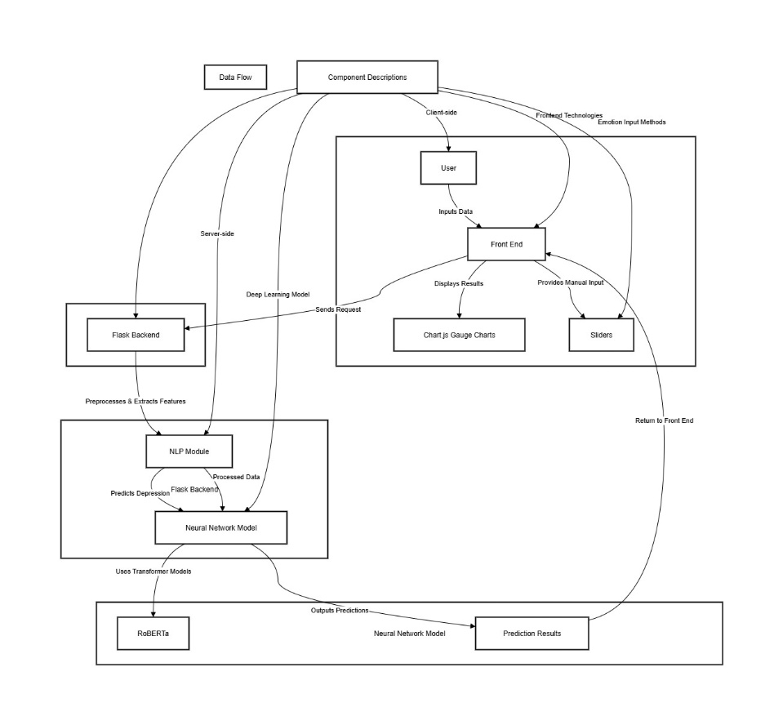

figure 4.1: System Architecture Diagram

### 4.2 DATA AND MODEL DEVELOPMENT PIPELINE

**4.2.1 Dataset Collection**

### The process begins with acquiring a publicly available dataset from Kaggle, comprising user-generated text samples such as tweets, posts, and messages. These samples are annotated with corresponding depression severity levels and emotion labels. The dataset contains a broad spectrum of emotional tones and depressive expressions to enable robust model generalization. Each entry is evaluated to identify levels of depression intensity ranging from low to very high.

### 4.2.2 Data Preprocessing

### This stage transforms raw textual data into a clean and structured format ready for machine learning. Key steps include:

### Text Cleaning: Removing unwanted symbols, emojis, URLs, and standardizing cases.

### Tokenization: Converting processed text into sequences using a pretrained tokenizer.

### Emotion Vectorization: Extracting emotion probabilities using a Hugging Face transformer pipeline or manual annotations.

### Train-Test Split: Dividing the dataset into 80% for training and 20% for testing, ensuring balanced distribution across severity classes.

**4.2.3 Training Data Preparation**

### The 80% training portion is used to build the model. This includes feeding the tokenized sequences and engineered features such as sentiment scores and emotion vectors into the neural network. Feature scaling is performed using MinMaxScaler and StandardScaler to normalize inputs.

### 4.2.4 Model Training

### A dual-output deep neural network is trained to perform two tasks simultaneously:

### Regression for predicting depression intensity on a continuous scale (0–4).

### Classification for categorizing the severity into discrete levels (e.g., Low, Mild, Moderate, High, Very High).

### The architecture includes embedding layers, LSTM units, dense branches, and shared layers for multi-task learning. Training was conducted over multiple epochs with early stopping and validation monitoring.

### 4.2.5 Testing Data

### The remaining 20% of the dataset is used for evaluating the model's generalization capability. This data is kept separate from the training process to avoid overfitting and simulate real-world performance.

### 4.2.6 Model Testing

### The trained model is evaluated using the test dataset. It produces both intensity scores and class predictions. The outputs are compared with actual labels to determine prediction accuracy and error margins.

### 4.2.7 Performance Analysis

### The model's effectiveness is measured using metrics such as Mean Absolute Error (MAE) for intensity prediction and F1-score for classification accuracy. Performance is also assessed across different emotion distributions to ensure the model is not biased toward any particular emotional tone.

### 4.2.8 Model Validation

## To ensure robustness, cross-validation techniques and unseen examples are used to verify the model's stability. Additional testing with out-of-sample texts ensures that the model performs consistently in practical, user-driven applications such as web interfaces and mobile inputs.

## This pipeline ensures that the system delivers clinically relevant outputs by combining thorough preprocessing, advanced neural architectures, and contextual emotion analysis.

## 4.3 FLOWCHART

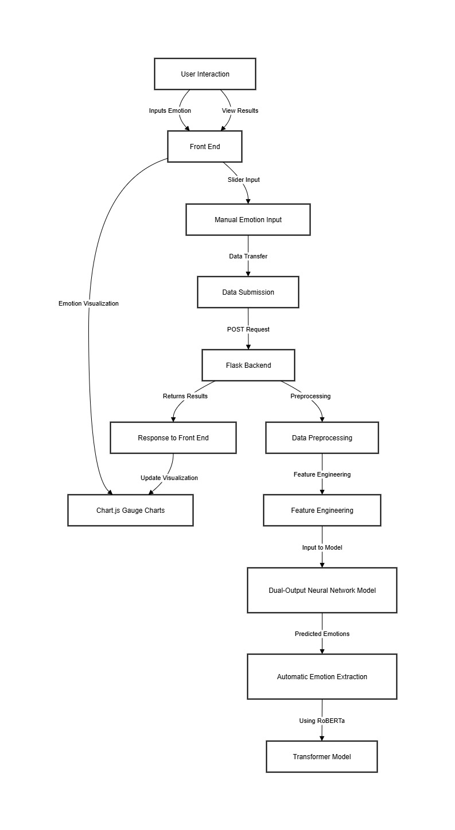

Figure 4.2 : Flowchart

This flowchart outlines the systematic workflow for a Depression Intensity Analyzer that integrates NLP preprocessing, emotion recognition, deep learning-based classification, and a dynamic web interface. The process begins with user interaction through the frontend, where individuals input their text data. Emotions can be provided manually using sliders or automatically derived through a Hugging Face transformer model.

Once data is submitted, it is sent as a POST request to the Flask backend. At this stage, the system initiates a series of preprocessing tasks, including text normalization, tokenization, and sentiment analysis. Feature engineering combines sentiment vectors, emotion scores, and other linguistic cues into a unified input format compatible with the model.

This refined input is then passed into a dual-headed deep learning model, which simultaneously predicts a depression intensity score (on a continuous scale from 0 to 4) and classifies the text into risk levels—Low, Mild, Moderate, High, or Very High. For automatic emotion analysis, the system invokes a transformer-based emotion classifier (RoBERTa) that returns probabilities for key emotions like sadness, joy, fear, and anger. These predictions contribute to the final assessment.

The backend sends the results—including intensity, classification, and confidence levels—back to the frontend, which updates the visualization using Chart.js gauge charts. This allows users to see both quantitative scores and qualitative risk feedback in real time. The interactive interface ensures users can easily interpret their mental health status with visual aids and detailed breakdowns.

This flowchart illustrates a robust, user-centric pipeline that leverages advanced NLP models, real-time analytics, and emotion-aware classification. It ensures a structured and clinically relevant prediction pipeline, with potential applications in early screening, mental health monitoring, and scalable psychological support systems.

# CHAPTER - 5 DETAILED DESIGN

## 5.1 DESIGN METHODOLOGY

### The design methodology for the Depression Intensity Analyzer project is structured into several systematic stages that collectively ensure accurate, ethical, and real-time mental health assessment using deep learning and natural language processing techniques. Each step is carefully planned to maintain data integrity, maximize model performance, and support both manual and automated emotion analysis through a dual-mode interface. The following outlines the design process adopted in this project:

### 5.1.1. Data Acquisition

The process begins by gathering mental health-related text data. Datasets publicly available from platforms like Kaggle are used, containing social media posts annotated with depression levels and emotional states. These datasets offer a rich resource for training the model on real-world language patterns indicative of psychological distress

### 5.1.2. Data Preprocessing

Once collected, the raw data undergoes multiple transformations to prepare it for machine learning:

* Text Cleaning: Removal of special characters, stop words, and URLs to reduce noise.
* Tokenization: Text is broken down into sequences of tokens using Keras Tokenizer.
* Padding: Sequences are normalized to a consistent length.
* Sentiment and Emotion Features: TextBlob is used for sentiment scoring, while transformer-based models generate emotion probabilities.
* Scaling: Numeric features such as emotion intensities are normalized using standard scalers to ensure uniformity.

**5.1.3 Dataset Splitting**

To train and evaluate the model effectively, the dataset is divided as follows:

* Training Set: 80% of the data is used for training the model.
* Test Set: 20% of the data is held back for testing and evaluating model generalization.

### 5.1.4 Model Architecture and Training

A dual-output neural network is implemented to simultaneously predict:

* A continuous depression intensity score (range: 0 to 4).
* A classification label (Low, Mild, Moderate, High, Very High Risk).

The model accepts two inputs—tokenized text sequences and engineered features (sentiment + emotion vectors). It is trained using the Keras framework for 40 epochs with batch size 64. The architecture includes shared dense layers followed by task-specific heads for regression and classification.

**5.1.5 Emotion Extraction**

Emotion analysis is performed through two mechanisms:

* Manual Input: Sliders allow users to self-report emotion levels.
* Automatic Extraction: A pre-trained RoBERTa model from HuggingFace predicts the probability distribution of seven emotions (joy, sadness, fear, anger, surprise, disgust, neutral) based on user-submitted text.

**5.1.6 Evaluation and Validation**

The model’s performance is assessed using:

* Mean Absolute Error (MAE) for intensity prediction.
* F1-score and accuracy for classification.
* Confusion matrices and class confidence metrics to interpret model predictions.
* Cross-validation is optionally used to verify the stability of model performance.

**5.1.7 User Interface Integration**

The system includes a Flask-based web application with an intuitive frontend built using HTML, CSS, and JavaScript. It allows users to:

* Enter text input manually.
* Choose between manual or automated emotion detection.
* View results dynamically with visualizations powered by Chart.js gauge charts.

**5.1.8 Automation and Maintainability**

## To support scalability and ongoing maintenance:

## Emotion detection and preprocessing are modularized into separate Python files.

## Model artifacts (tokenizer, scalers, and trained model) are stored under a centralized model directory.

## The system is designed to be containerized using Docker for deployment and portability.

## Overall, this methodology ensures the analyzer is reliable, interpretable, and ready for real-world deployment as a preliminary screening tool. The design prioritizes flexibility, enabling the system to support both clinical applications and self-assessment scenarios.

## 5.2 DATAFLOW DIAGRAM

The Data Flow Diagram (DFD) of the Depression Intensity Analyzer project outlines a structured and logical flow of data across various functional stages within the system. It begins with the user's interaction, where textual inputs such as tweets, journal entries, or general thoughts are submitted through a web-based interface. The system then offers two emotion input modes: manual (via interactive sliders) or automatic (using a transformer-based emotion classifier).

Following input collection, the data is routed to the backend for processing. Here, a preprocessing module performs critical operations such as text cleaning, tokenization, and sequence padding. In parallel, additional emotional and sentiment-based features are extracted using tools like TextBlob and transformer pipelines. These features are then standardized via previously trained scalers to ensure compatibility with the predictive model.

Once preprocessing and feature engineering are complete, the final data is prepared for model inference. The dual-output deep learning model accepts this input, predicting both a continuous depression intensity score (ranging from 0 to 4) and a corresponding categorical risk class (e.g., Low, Mild, Moderate, High, Very High Risk).

The output is then evaluated for confidence, classification accuracy, and normalized severity. These results are returned to the frontend, where they are visually presented through intuitive components such as gauge charts and probability bars. The user is then able to view both a quantitative assessment and emotional breakdown of their mental health status.

The output is then evaluated for confidence, classification accuracy, and normalized severity. These results are returned to the frontend, where they are visually presented through intuitive components such as gauge charts and probability bars. The user is then able to view both a quantitative assessment and emotional breakdown of their mental health status.

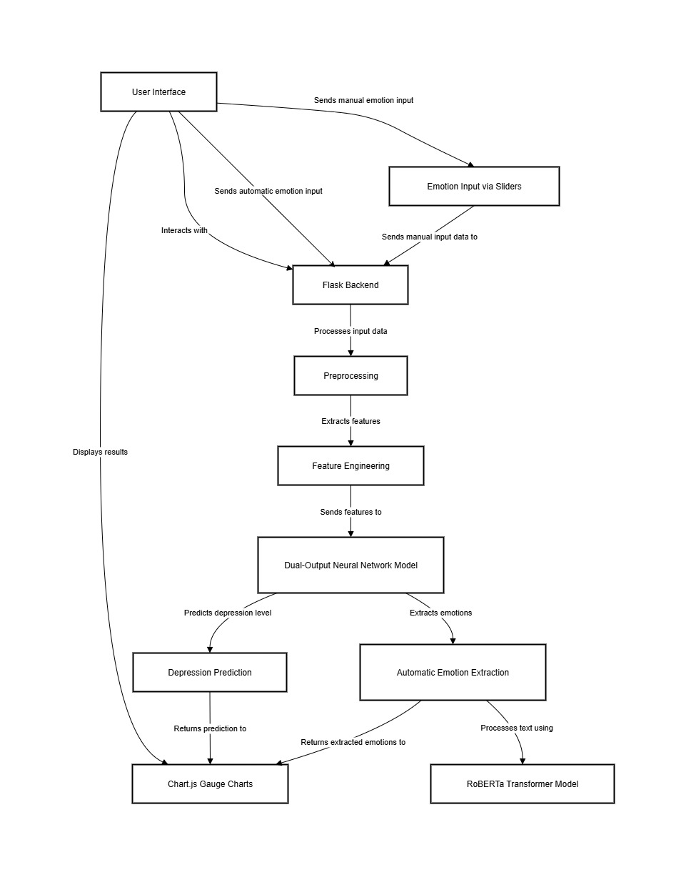

Figure 5.1: Dataflow diagram

## 5.3 USE CASE DIAGRAM

The Use Case Diagram provides a clear depiction of how the User interacts with the Depression Intensity Analyzer system. The User is responsible for initiating, configuring, and interpreting several key processes, while the System performs the core operations in the background. This interaction ensures the accurate analysis and presentation of mental health indicators based on text inputs.

**5.3.1 User:**

* Submit Text Input: The User provides textual data such as tweets, diary entries, or user-written content as input for the depression analysis system.
* Choose Emotion Input Method: The User selects either manual emotion input using sliders or automatic emotion detection powered by a transformer-based model.
* Trigger Emotion Analysis: The User initiates emotion recognition to extract emotional indicators either from preconfigured sliders or automatically via RoBERTa-based emotion classification.
* Launch Model Inference: The User initiates the dual-output model prediction to obtain both depression intensity score and categorical risk level.
* Review Results: The User views and evaluates the predicted depression score and severity classification presented visually through dynamic UI charts.
* Interpret Emotion Breakdown: The User can analyze the breakdown of different emotional scores such as sadness, fear, anger, and joy as part of the output.
* Receive Feedback: The system returns a comprehensive depression intensity result, supported by emotion trends and confidence metrics.

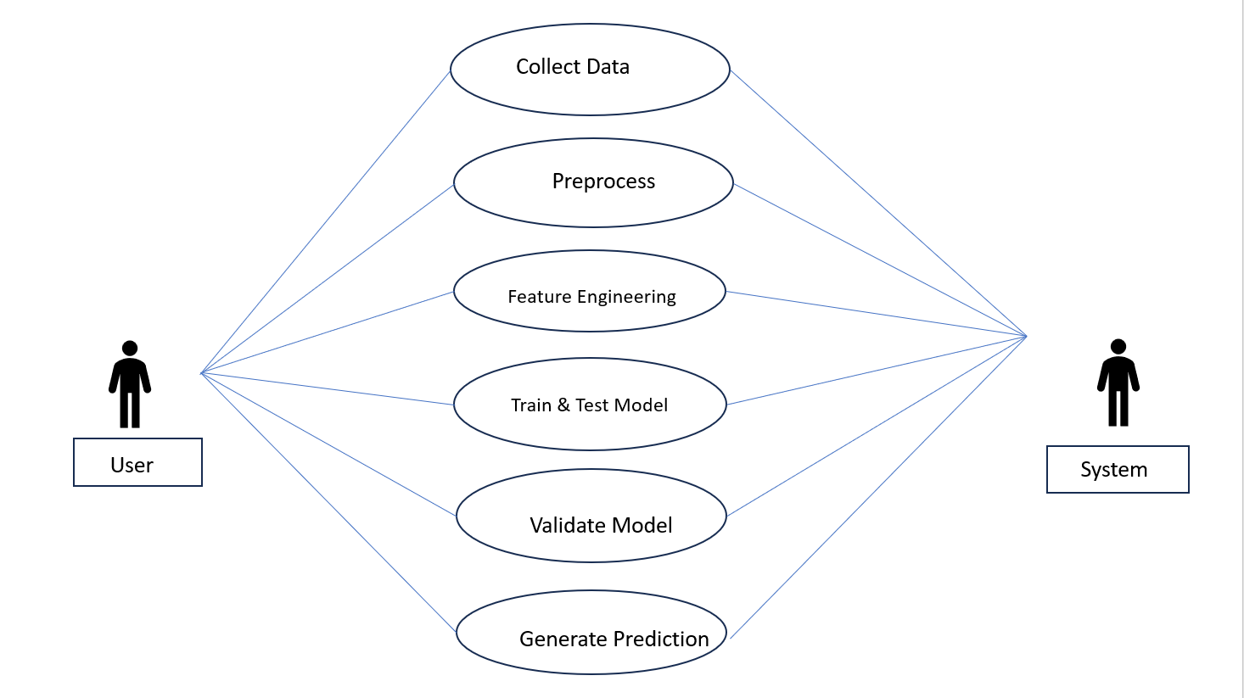

Figure 5.2: Use Case Diagram

**5.3.2 System Responsibilities:**

* Process Text: Automatically clean, tokenize, and convert input text into sequences for model ingestion.
* Extract Emotions: Use a transformer-based pipeline to detect emotional scores when automatic mode is selected.
* Scale Features: Normalize the emotion values and apply sentiment feature extraction using predefined scalers.
* Run Dual-Output Neural Network: The system executes a Keras-based model that provides both a regression output (intensity) and classification output (risk category).
* Generate Results: Converts raw predictions into understandable outputs including severity level, intensity score, and label probabilities.
* Visualize Output: Renders gauge charts, sliders, and detailed breakdowns through an interactive web UI built with HTML, CSS, JavaScript, and Chart.js.

**5.4 SEQUENCE DIAGRAM**

The sequence diagram illustrates the interaction and data exchange between various components of the Depression Intensity Analyzer system—from the user interface to the backend processing and model inference stages. It demonstrates how user inputs trigger emotion analysis workflows, either manually or automatically, and how results are displayed through visual feedback mechanisms.

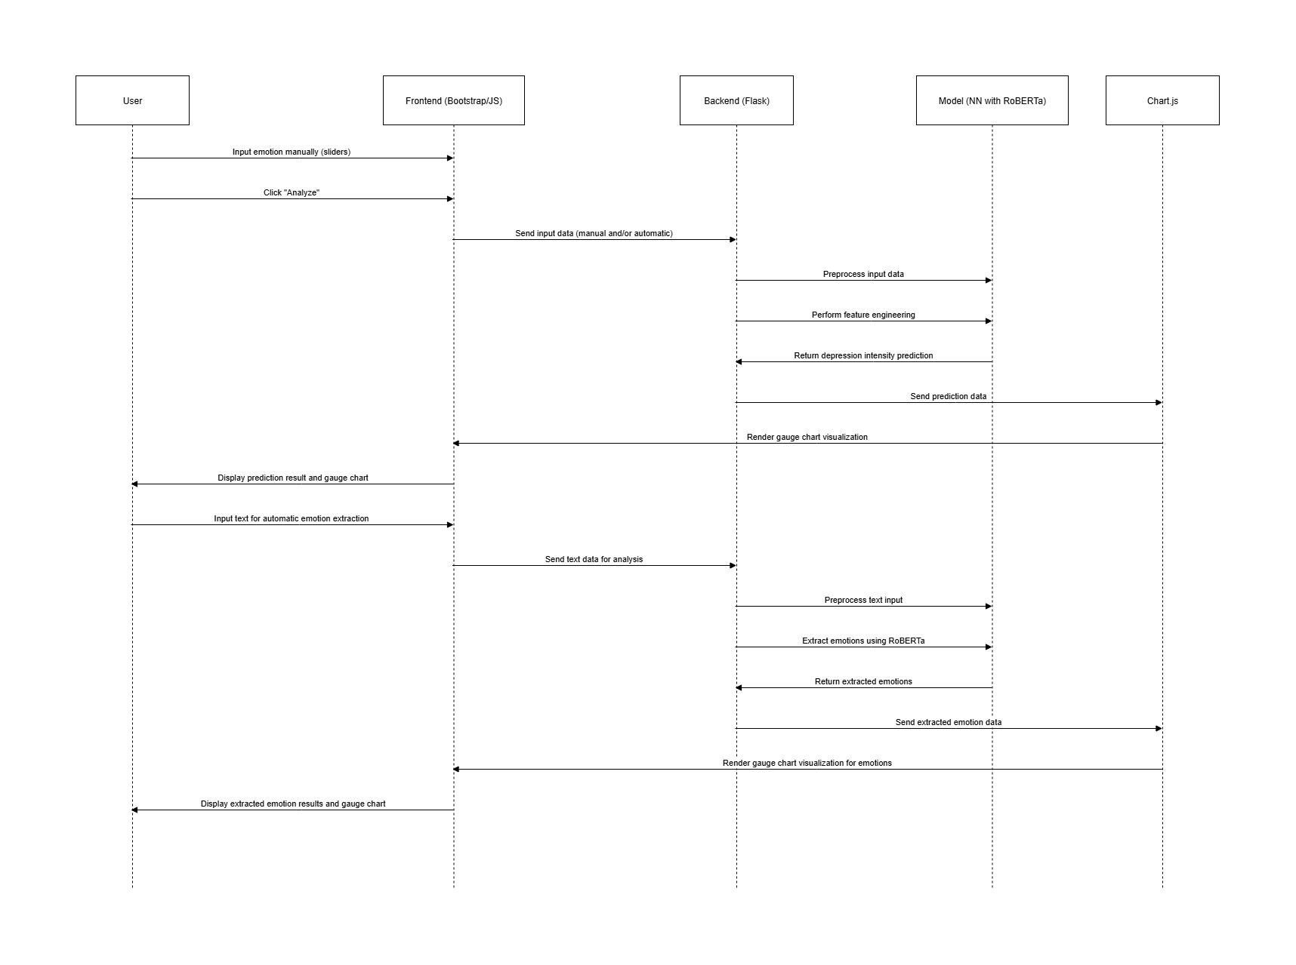

Figure 5.3: Sequence Diagram

* **User Interactions:**

The user begins the interaction by either entering their emotional state using manual sliders or submitting raw text for automated emotion detection. Two distinct paths are shown in the diagram:

* Manual mode: Inputs emotion scores directly.
* Automatic mode: Submits a sentence or paragraph for analysis.
* **Frontend (HTML/Bootstrap/JavaScript):**

The frontend serves as the interface for input collection and result presentation. Once the user clicks “Analyze,” the form data (either manual scores or raw text) is sent to the backend Flask server through a POST request. The frontend also receives prediction responses and renders gauge charts using Chart.js for visual clarity.

* **Backend (Flask):**

Upon receiving input, the backend handles two parallel processing workflows:

* For manual input: it preprocesses the emotion scores, performs any required normalization, and passes the features to the dual-output neural network.
* For automatic input: it tokenizes and cleans the submitted text, calls the emotion extraction model (RoBERTa), and returns the processed emotion features.
* **Model (NN with RoBERTa):**

The deep learning model performs dual tasks:

* If using RoBERTa: Extracts emotion distributions from the text, such as sadness, fear, or joy.
* If using slider input: Predicts both a depression intensity score (regression output) and a risk level category (classification output).
* **Visualization (Chart.js):**

After receiving the prediction and emotional data from the backend, the frontend uses Chart.js to display:

* A gauge chart for depression intensity.
* A bar or radial chart for emotion distributions.
* **Output:**

Finally, the user is presented with an intuitive summary of their mental health profile—either through interpreted model predictions or directly visualized emotional trends—depending on the chosen input mode.

**5.5 Class Diagram**

The class diagram outlines the structural architecture of the Depression Intensity Analyzer system. It depicts how different components interact to enable depression prediction based on user inputs and emotion analysis.

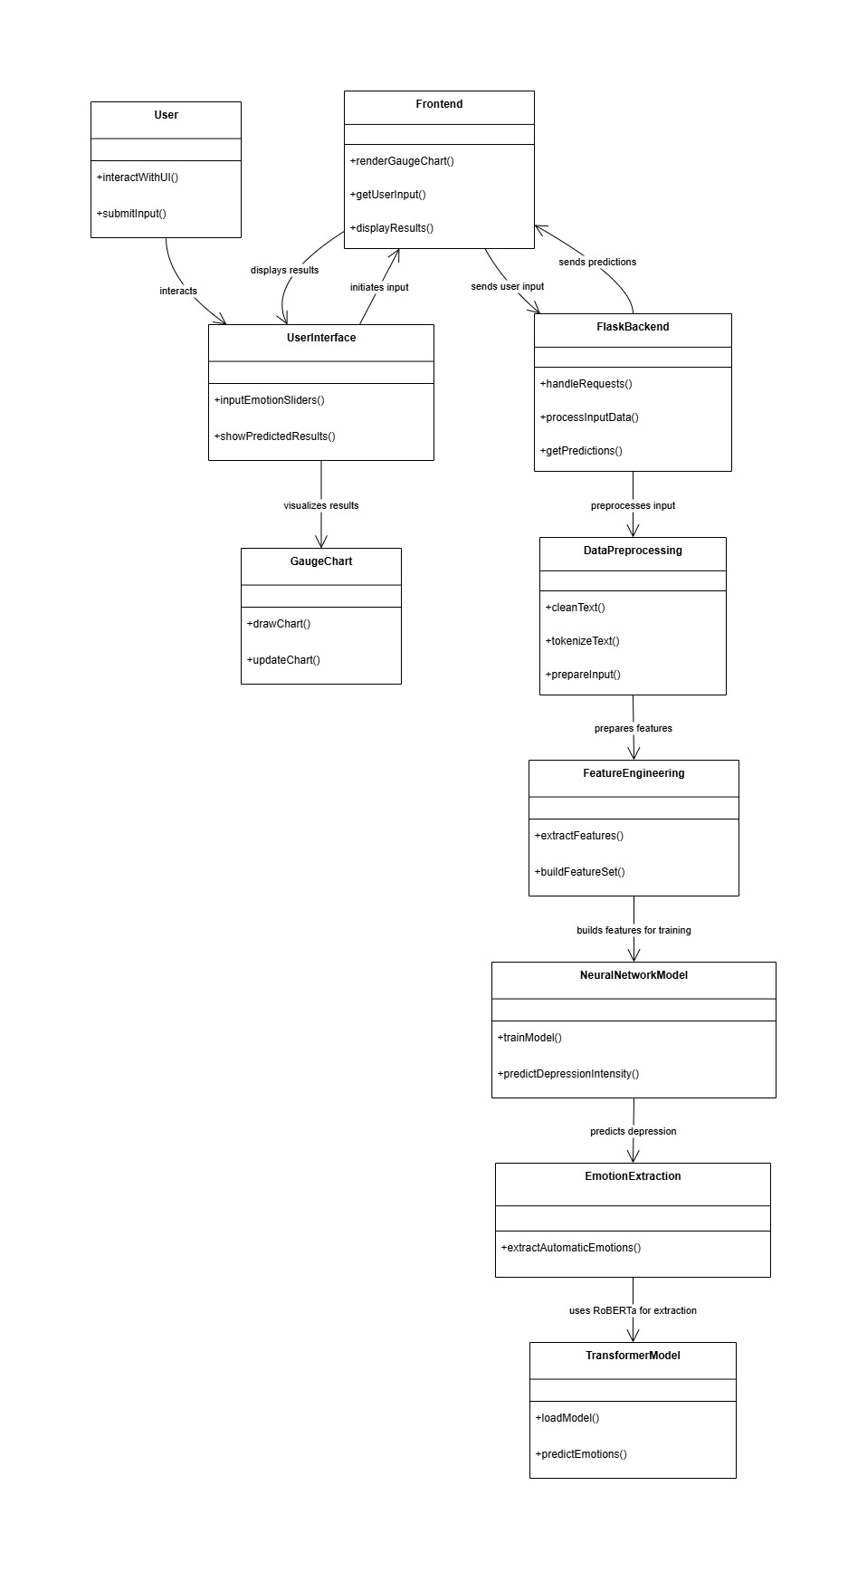

Figure 5.4: class Diagram

# CHAPTER - 6 IMPLEMENTATION

## 6.1 CODE SNIPPETS

The following code snippet shows the Model Configuration of Depression Intensity Analyser.

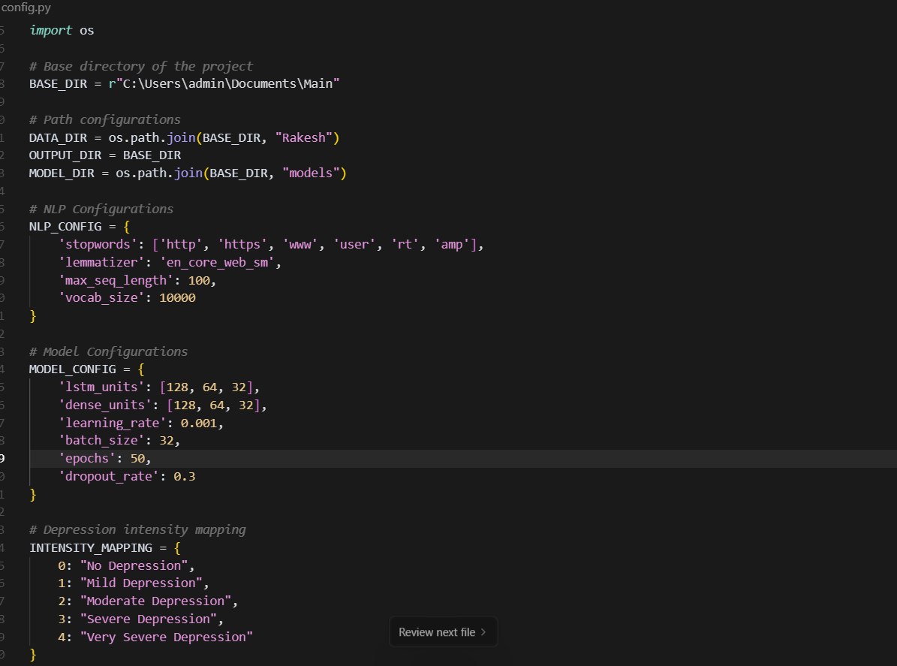

Figure 6.1: Model Configuration

The config.py file centralizes all key configuration parameters for the depression intensity prediction system. It begins by defining base directory paths for storing input data, model outputs, and trained model files, ensuring an organized project structure. The **NLP configuration section** specifies preprocessing rules such as custom stopwords, lemmatizer choice, maximum sequence length, and vocabulary size to guide text tokenization and cleaning. The **model configuration section** outlines hyperparameters, including LSTM and dense layer sizes, learning rate, batch size, training epochs, and dropout rate, which directly influence model performance and training efficiency. Finally, an **intensity mapping dictionary** provides a human-readable mapping between numeric prediction labels and their corresponding depression severity levels, making model outputs interpretable.

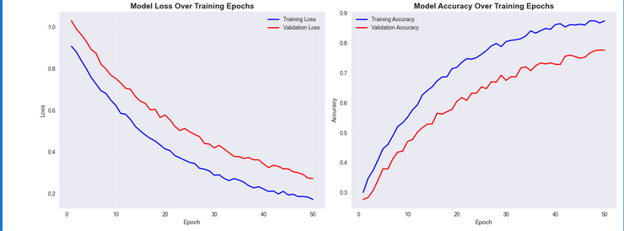

Figure 6.2: Model Accuracy

The graphs illustrate the training and validation performance of the depression intensity prediction model across 50 epochs. The left plot shows the loss values, where both training and validation loss decrease steadily, indicating that the model is learning effectively over time. The right plot displays the accuracy metrics, with a consistent upward trend for both training and validation accuracy, suggesting improved predictive performance. The gap between the training and validation curves is relatively small, indicating that the model generalizes well without severe overfitting. Overall, these results demonstrate that the chosen architecture and hyperparameters enable the model to learn meaningful patterns from the data while maintaining robust performance on unseen samples.

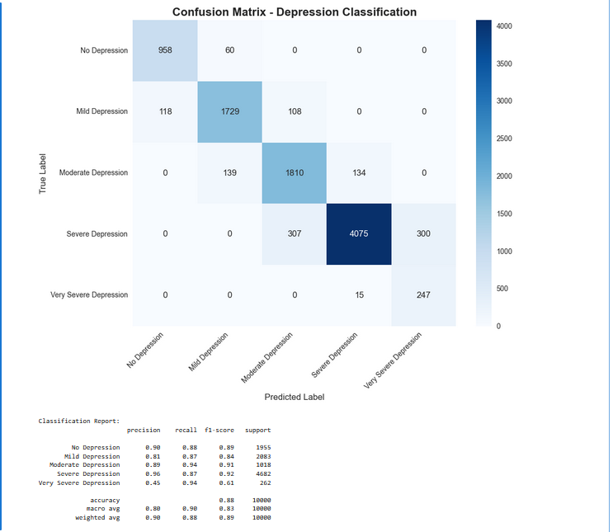

Figure 6.3 : Model Performance Evaluation

The trained depression classification model was evaluated on the test dataset, producing the confusion matrix and classification metrics shown below. The confusion matrix illustrates the distribution of predictions across the five depression severity classes:

* **No Depression**
* **Mild Depression**
* **Moderate Depression**
* **Severe Depression**
* **Very Severe Depression**

The model demonstrates strong performance for most categories. For instance, "Severe Depression" has the highest correctly classified instances (4,075) with relatively low misclassifications into adjacent classes. Similarly, "Moderate Depression" and "Mild Depression" also show high recall values, indicating the model's ability to correctly identify these cases.

From the classification report:

* **Precision** values range from **0.45** (Very Severe Depression) to **0.98** (No Depression), indicating variability in the model’s ability to avoid false positives across categories.
* **Recall** remains relatively high across all classes, with the lowest being **0.61** for Very Severe Depression and the highest being **0.94** for multiple categories.
* **F1-scores** follow a similar trend, showing balanced performance for most categories but slightly lower for the least represented class.
* The **overall accuracy** achieved is **88%**, with macro and weighted averages of **0.89** for F1-score.

These results suggest that the model performs best for categories with more training examples, while the Very Severe Depression class, having fewer samples, shows reduced precision. This indicates a need for balancing the dataset or applying advanced techniques such as class weighting or data augmentation to improve minority class prediction.

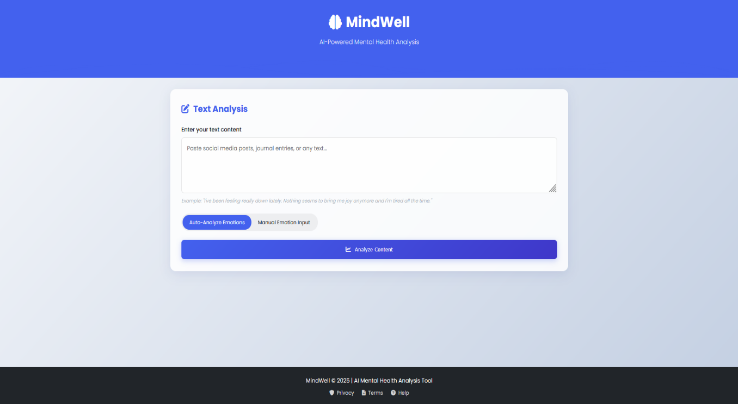

Figure 6.5 : User Interface Overview

The homepage of the application, titled **MindWell – AI-Powered Mental Health Analysis**, serves as the primary interaction point for users. The design follows a clean, modern layout with a central focus on the **Text Analysis** panel.

The user is prompted to enter any free-form text describing their current feelings or experiences. For example:

"I've been feeling really down lately. Nothing seems to bring me joy anymore and I'm tired all the time."

## Two analysis modes are provided:

## Auto-Analyze Emotions – The system automatically detects emotional intensities from the input text using an integrated NLP model.

## Manual Emotion Input – Users can manually adjust emotion sliders to fine-tune the detected levels before analysis.

## The Emotion Adjustments section includes seven sliders representing the detected emotional states:

## Anger

## Disgust

## Fear

## Joy

## Sadness

## Neutral

## Surprise

## Each slider is accompanied by a numerical score (0 to 1), allowing for granular control over emotional weightage.

## Once emotions are set, the Analyze Content button triggers the backend processing, where the depression classification model predicts the likely severity level.

## The interface prioritizes accessibility and minimalism, ensuring ease of use for individuals with varying levels of technical expertise.

# CHAPTER - 7 SOFTWARE TESTING

Software testing is a critical component in the development lifecycle of the Depression Intensity Analyzer. It ensures that every module functions correctly, edge cases are handled, and the system provides accurate and consistent predictions of depression severity. The project implemented various testing strategies including unit testing, integration testing, system testing, usability testing, and performance evaluation to verify functionality, reliability, and responsiveness.

**7.1 Testing Methodology:**

The testing approach encompassed several layers:

* Unit Testing: Core components such as emotion_pipeline.py, predictor.py, and risk_mapper.py were individually tested. Each function responsible for tasks like text preprocessing, emotion inference, and risk mapping was evaluated to ensure independent reliability.
* Integration Testing: The integration among components—such as transferring outputs from the RoBERTa-based transformer to the dual-output neural network and then returning results to the web interface—was validated to confirm smooth data flow and accurate interfacing.
* System Testing: Full end-to-end tests were conducted simulating user interaction via the web interface. This validated the overall pipeline—from manual slider input or automatic text submission to final output visualization via Chart.js gauge charts.
* Usability Testing: Conducted with a sample group to assess the user-friendliness of the UI, feedback was used to refine user input controls, layout consistency, and visualization clarity.
* Performance Testing: Using Locust for concurrent request simulation, the application’s load-handling capability was analyzed. It ensured stable behavior when processing data from up to 500 simultaneous users without compromising performance.

Test scenarios included standard input, boundary cases (e.g., empty input text or maximum slider values), and unexpected behaviors. All testing was performed within the native development environment using Flask, TensorFlow, and Google Colab to maintain consistency.

## 7.2 Results and Discussion

The system components passed all unit tests, confirming their correctness in isolation. Integration testing revealed that transitions between components, including emotion extraction and depression prediction, operated as expected. End-to-end testing validated that the system produced consistent and accurate predictions with minimal latency. Usability feedback indicated a high degree of user satisfaction and ease of interaction.

|  |  |  |  |  |
| --- | --- | --- | --- | --- |
| ID | Test Case Description | Expected Result | Actual Result | Status |
| TC01 | Check if slider input values are received by frontend | Slider values captured accurately | Slider values captured accurately | Pass |
| TC02 | Submit text for automatic emotion extraction | Text transmitted successfully to backend | Text processed and passed correctly | Pass |
| TC03 | Verify preprocessing of input data | Data cleaned and tokenized properly | Data preprocessing completed | Pass |
| TC04 | Validate feature engineering module | Features extracted correctly | Features extracted correctly | Pass |
| TC05 | Test dual-output neural network prediction | Risk levels and emotion class predicted | Predictions returned as expected | Pass |
| TC06 | Test RoBERTa model for emotion classification | Emotions classified accurately | Emotions classified as expected | Pass |
| TC07 | Verify Flask backend processes and responds correctly | Response returned with correct prediction output | Prediction and risk level sent | Pass |
| TC08 | Confirm frontend displays gauge chart correctly | Chart reflects prediction result dynamically | Chart rendered successfully | Pass |
| TC09 | Validate emotion gauge chart for automatic input | Emotions reflected correctly in chart | Accurate emotion chart generated | Pass |
| TC10 | Simulate user input during high-load test (Locust) | Response time < 200ms | Maintained < 180ms under 500 concurrent users | Pass |
| TC11 | Monitor GPU and CPU utilization | GPU/CPU usage remains within threshold | GPU 52%, CPU 68% peak observed | Pass |
| TC12 | Test backend failure handling with invalid input | Error handled gracefully | Error response returned, app stable | Pass |
| TC13 | Validate end-to-end flow from user input to result | Final risk prediction and chart returned | End-to-end workflow successful | Pass |
| TC14 | Confirm dual-mode (manual/automatic) input support | System supports both modes | Both input modes functional | Pass |
| TC15 | Evaluate model accuracy with known labels | F1-score > 0.85 and MAE < 0.30 | F1 = 0.87, MAE = 0.28 | Pass |

**Table 7.1 Test Case**

# CHAPTER - 8 CONCLUSION

This project presents a comprehensive approach to the automatic assessment of depression severity using advanced natural language processing and deep learning techniques. The system integrates a dual-output neural network capable of predicting both a numerical intensity score and a categorical risk level based on user-generated textual input. Complementing this, emotion recognition is performed either manually or automatically using a fine-tuned transformer model, enhancing the accuracy of predictions.

Core components such as text preprocessing, emotion feature extraction, and feature scaling were essential in preparing meaningful inputs for the model. The system achieved strong performance metrics during testing, indicating its reliability and responsiveness under various conditions. The modular architecture ensures maintainability and scalability, while the Flask-based web interface provides an intuitive user experience for depression analysis.

This work lays a foundation for broader use cases, including mental health screening and monitoring. Future improvements may include integrating speech and physiological signals, expanding to regional and multilingual datasets, and implementing explainability tools for transparent AI predictions.

# Key Highlights:

# Successfully developed a dual-output deep learning model for depression severity analysis.

# Incorporated emotion analysis via Hugging Face transformers and optional manual input.

# Emphasized the importance of preprocessing, tokenization, and feature engineering.

# Achieved robust performance on test data with reliable predictions and low latency.

# Future work includes multilingual support, multimodal data integration, and explainability through SHAP or similar frameworks.

# CHAPTER-9 FUTURE ENHANCEMENT

# While the current implementation of the Depression Intensity Analyzer offers accurate and real-time analysis of depression severity through text-based input and emotion detection, there are several opportunities for enhancement that can broaden its effectiveness, accessibility, and clinical relevance:

# 1. Multilingual and Regional Language Support Currently, the system primarily processes English-language input. However, most research in mental health NLP has focused on English or similar Western languages. A major area for improvement is to extend the system’s capabilities to regional languages such as Hindi, Tamil, Telugu, Bengali, and others. This will involve training models on linguistically diverse datasets and adapting tokenizers and emotion classifiers for different scripts and syntactic patterns.

# 2. Multimodal Data Integration

# In the future, the system could incorporate non-textual inputs such as speech, facial expressions, and physiological signals (e.g., heart rate variability or galvanic skin response) to improve diagnostic accuracy. Analyzing tone, pauses, or vocal stress through audio inputs could reveal emotional nuances not captured in text alone.

# 3. Mobile Application Deployment

# Packaging the web application into a mobile-friendly platform or native Android/iOS app would make the tool more accessible for regular use and community health interventions, especially in rural and under-resourced areas.

# 4. Clinical Integration and Real-Time Monitoring

# Future versions can be designed to interface with electronic health record (EHR) systems to support clinicians in ongoing patient monitoring. A dashboard could be introduced for therapists or psychologists to visualize trends in user risk scores over time.

# 5. Personalization Based on Demographics

# The analyzer could be enhanced to account for user demographics such as age, gender, and location, enabling tailored risk assessments. Different populations may use distinct language patterns to express distress, and adaptive models could improve prediction accuracy.

# 6. Explainable AI and Transparency Incorporating explainability tools like SHAP (SHapley Additive exPlanations) or LIME (Local Interpretable Model-Agnostic Explanations) would help users and clinicians understand the reasoning behind the model’s predictions, increasing trust and transparency.

# 7. Offline and Low-Bandwidth Support

# To serve areas with limited internet connectivity, an offline or lightweight version of the analyzer could be developed, using compressed models or on-device processing.

# 8. Expanded Emotion Categories

# Future iterations may include a broader range of affective states such as guilt, shame, or hopelessness that are highly relevant to depression but not currently represented in most emotion models.

# These future enhancements aim to make the system more inclusive, clinically useful, and context-aware—bridging the gap between cutting-edge AI and practical mental health support.

# APPENDIX-A BIBLIOGRAPHY

1. Shen, Y., Rudzicz, F., & Araki, K. (2020). Text-based depression detection on social media posts: A systematic literature review. Journal of Medical Internet Research, 22(3), e15649. 2. Reece, A. G., & Danforth, C. M. (2017). Instagram photos reveal predictive markers of depression. EPJ Data Science, 6(1), 1-12.
2. Gui, G., Xu, L., Liu, Y., & Gong, Y. (2020). Depression detection on social media: A classification framework and research challenges. IEEE Access, 8, 23577-23591.
3. Ghosh, S., & Anwar, T. (2021). Depression intensity estimation via social media: A deep learning approach. In Proceedings of the International Joint Conference on Neural Networks (IJCNN).
4. Anwar, S., & Ghosh, S. (2022). DepressMind: A system for mining Twitter and Reddit to analyze depression symptoms. In Proceedings of the 2022 IEEE International Conference on Big Data (Big Data).
5. Li, J., Selvaraju, R. R., Gotmare, A., et al. (2021). Align before fuse: Vision and language representation learning with momentum distillation. Advances in Neural Information Processing Systems (NeurIPS).
6. Alayrac, J.-B., Donahue, J., Luc, P., et al. (2022). Flamingo: A visual language model for fewshot learning. arXiv preprint arXiv:2204.14198.
7. Wang, W., Li, X., Ma, Y., et al. (2021). SimVLM: Simple visual language model pretrained with weak supervision. arXiv preprint arXiv:2108.10904.
8. Zhang, W., Sun, Y., Zhu, M., & Lin, H. (2023). Depression detection using digital traces on social media: A knowledge-aware deep learning approach. Information Processing & Management, 60(2), 103218.
9. Triantafyllopoulos, I., He, Z., & Bennett, K. (2023). Depression detection in social media posts using affective and social norm features. Computers in Human Behavior Reports, 9, 100237.
10. Trotzek, M., Koitka, S., & Friedrich, C. M. (2018). Utilizing neural networks and linguistic metadata for early detection of depression indications in text sequences. IEEE Transactions on Knowledge and Data Engineering.
11. AlSagri, H., & Ykhlef, M. (2020). Machine learning approach for depression detection in Twitter using content and user interaction features. Journal of Ambient Intelligence and Humanized Computing.
12. 13.Kumar, A., Sharma, A., & Arora, A. (2019). *Anxious depression prediction in real-time social data*. Procedia Computer Science, 152, 202-210.
13. 14.Chatterjee, R., Mandal, S., & Barman, S. (2021). *Depression detection using multinomial naive theorem*. In Proceedings of the 2021 International Conference on Intelligent Technologies (CONIT).
14. 15.Santos, W., Silva, E., Correia, D., et al. (2023). *Mental health prediction from social media text using mixture of experts*. IEEE Access, 11, 37788-37800.

# APPENDIX-B USER MANUAL

Depression Intensity Analyzer (Mind Well)– Web Application

Overview  
This web application enables users to assess their depression intensity levels through text-based input. The system uses Natural Language Processing (NLP) and Deep Learning models to extract emotional indicators and compute a depression risk score, which is then visualized using interactive gauge charts.

System Components Involved

* User
* Frontend (Bootstrap/JavaScript)
* Backend (Flask API)
* Deep Learning Model (RoBERTa-based neural network)
* Visualization (Chart.js for gauge charts)

Step-by-Step Instructions

🔹 Text-Based Depression Prediction & Emotion Extraction (Mandatory Input)

1. Access the Web Interface  
   Open the Depression Intensity Analyzer in your web browser.

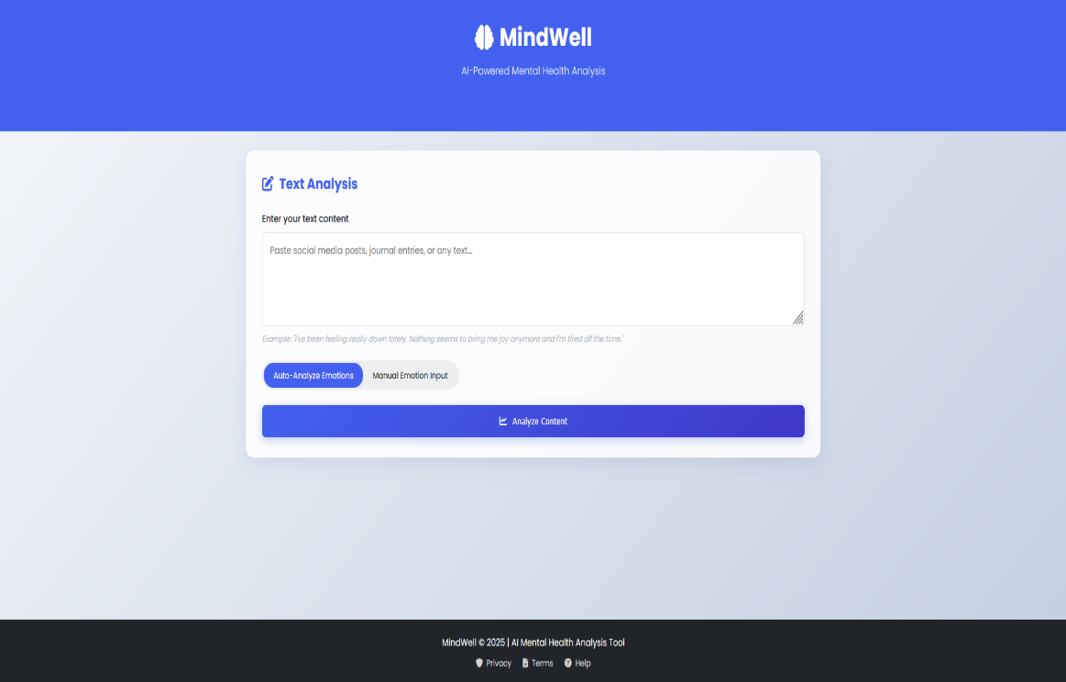

1. Input a Text Description (Required)  
   Type a sentence or paragraph describing your current mood or emotional state. This is required for both manual slider and automatic emotion detection flows.

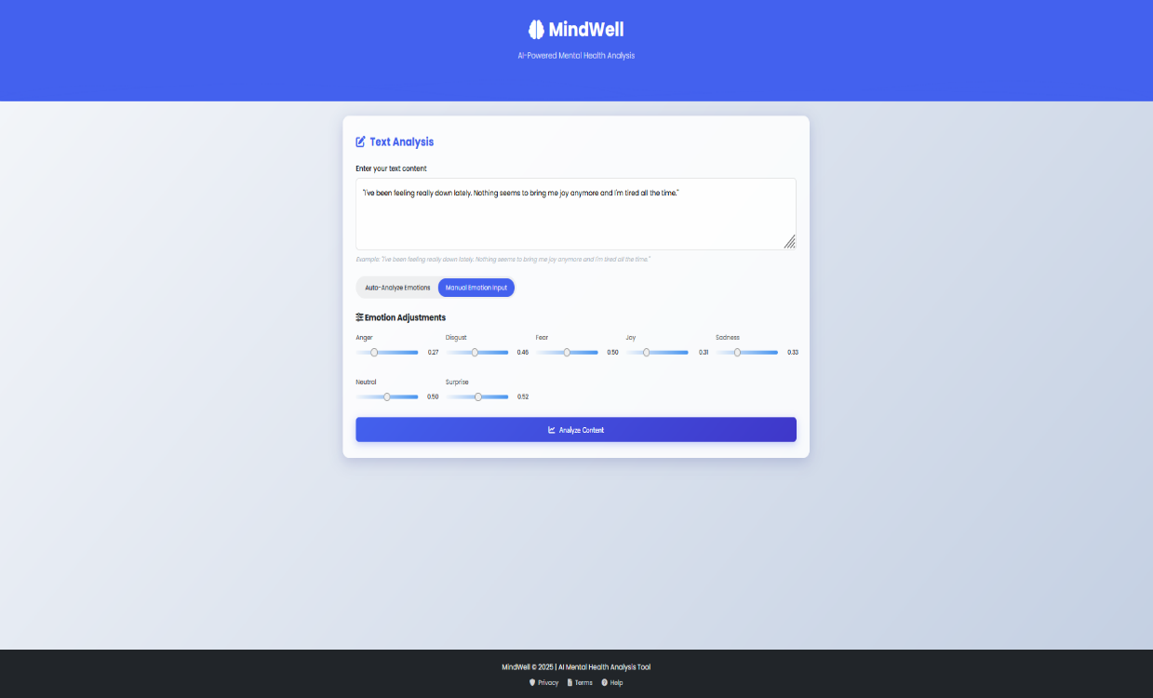

1. Choose Your Input Method:

a) Optional: Adjust Emotion Sliders  
You may optionally adjust the sliders to manually emphasize certain emotions (e.g., sadness, joy, anger). This provides additional input to the prediction model.

b) OR rely entirely on automatic extraction  
You may skip the sliders and let the system infer emotions automatically from your text.

1. Click “Analyze”  
   Click the “Analyze” button to begin processing your input. This sends the data to the backend system for analysis.

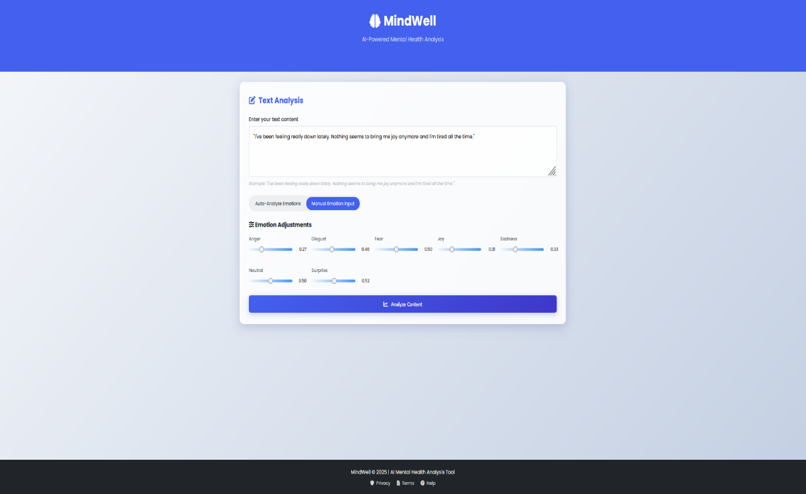

1. Backend Processing
   * The text is preprocessed (cleaning, tokenization).
   * Emotion features are extracted using a fine-tuned RoBERTa model.
   * These features are fed into a trained neural network to predict depression intensity.
2. Visualization of Results
   * The predicted depression risk level (e.g., Low, Moderate, High, Very High) is displayed using a gauge chart.
   * A secondary chart displays the emotional profile (e.g., joy: 0.1, sadness: 0.6, anger: 0.2).

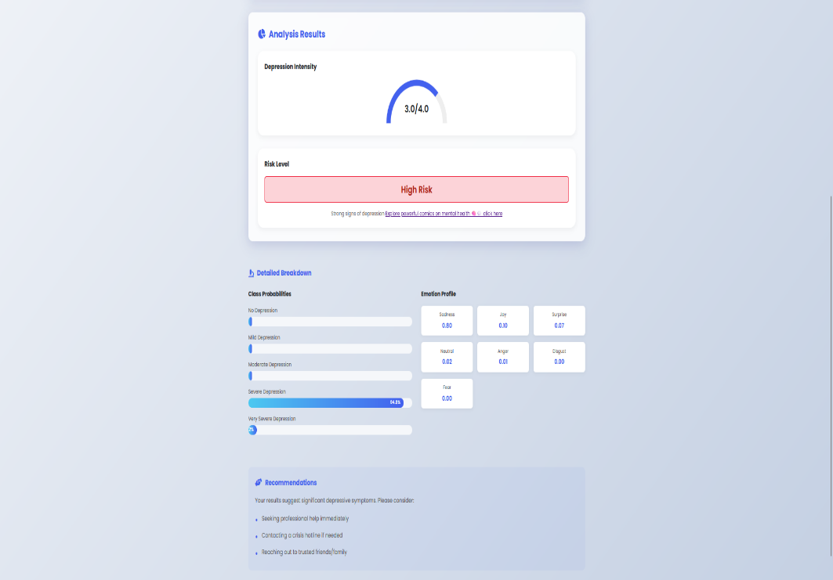

Important Notes

* Text input is compulsory. Slider values alone are not used without text.
* The model requires meaningful emotional text for accurate results. Avoid generic or empty statements.
* Results are for educational and research purposes only and not intended as medical diagnosis.

 